**Lab Assignment - 03**

Q1. Write a assembly program for Hello world and print it into console.

Ans :

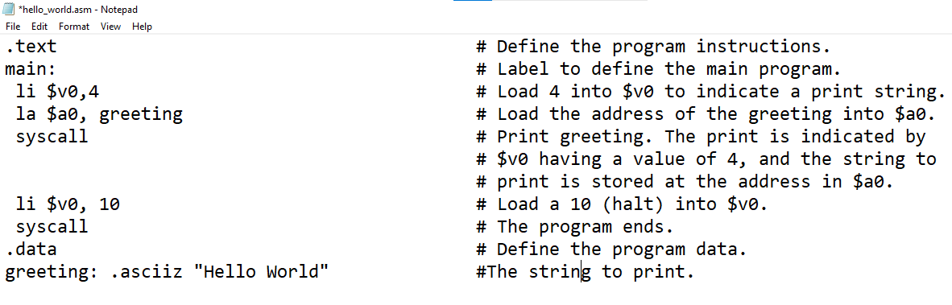

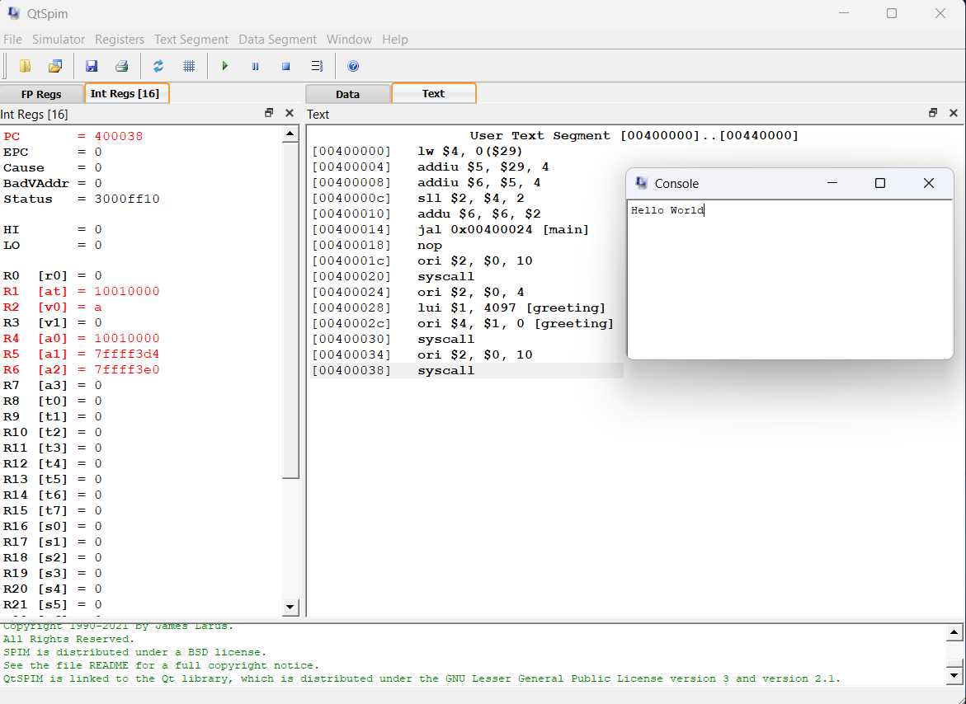

Q2. Write a program to read an integer number from user and print to the console.

ANS :

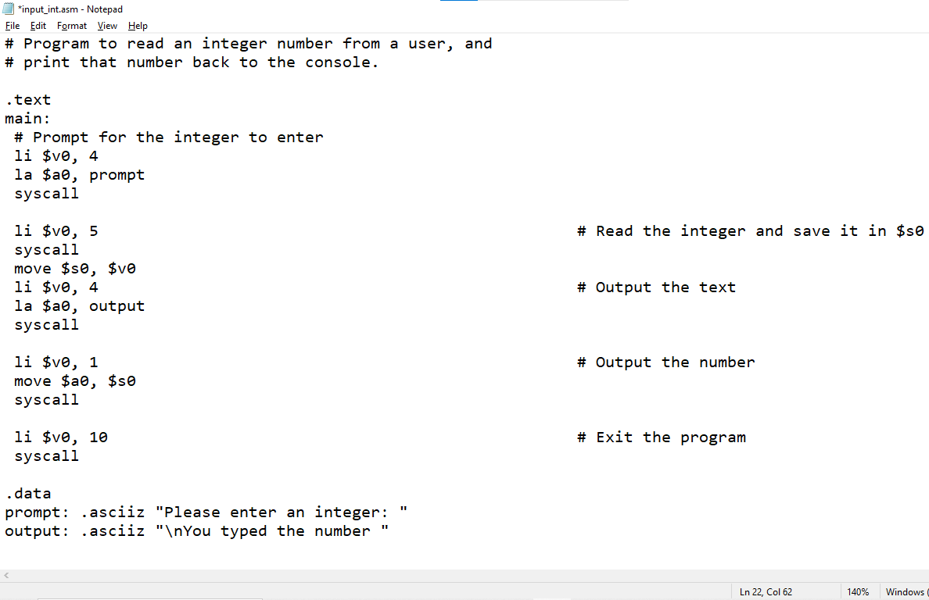

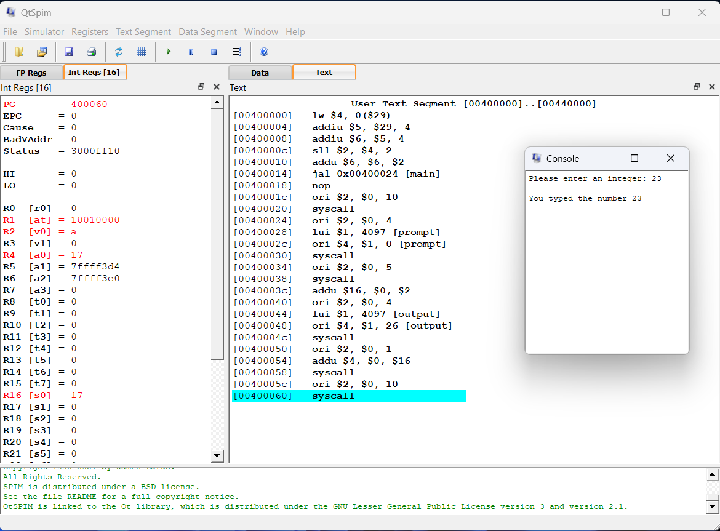

Q3. Program to prompt and read a string from a user.

ANS :

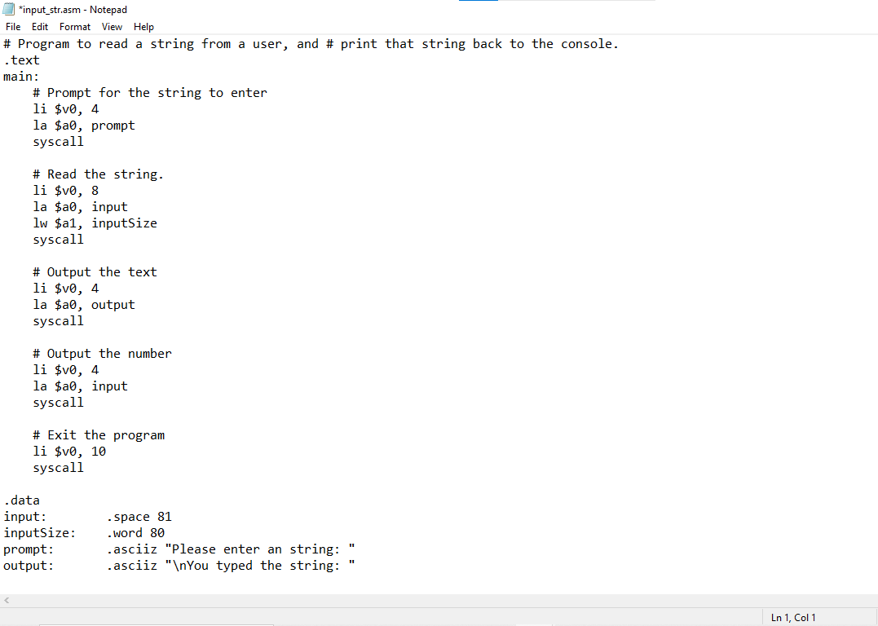

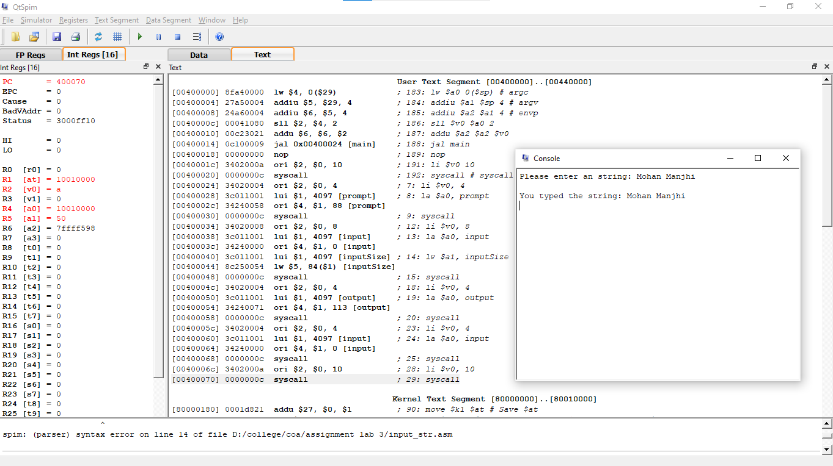

Q4. Write a program to print out a random number from 1..100.

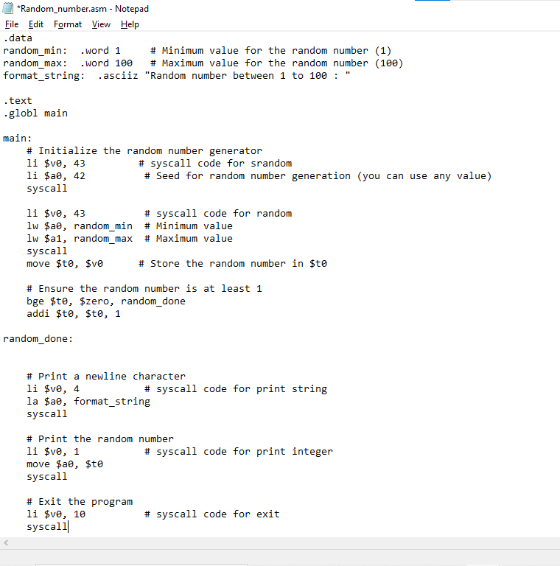

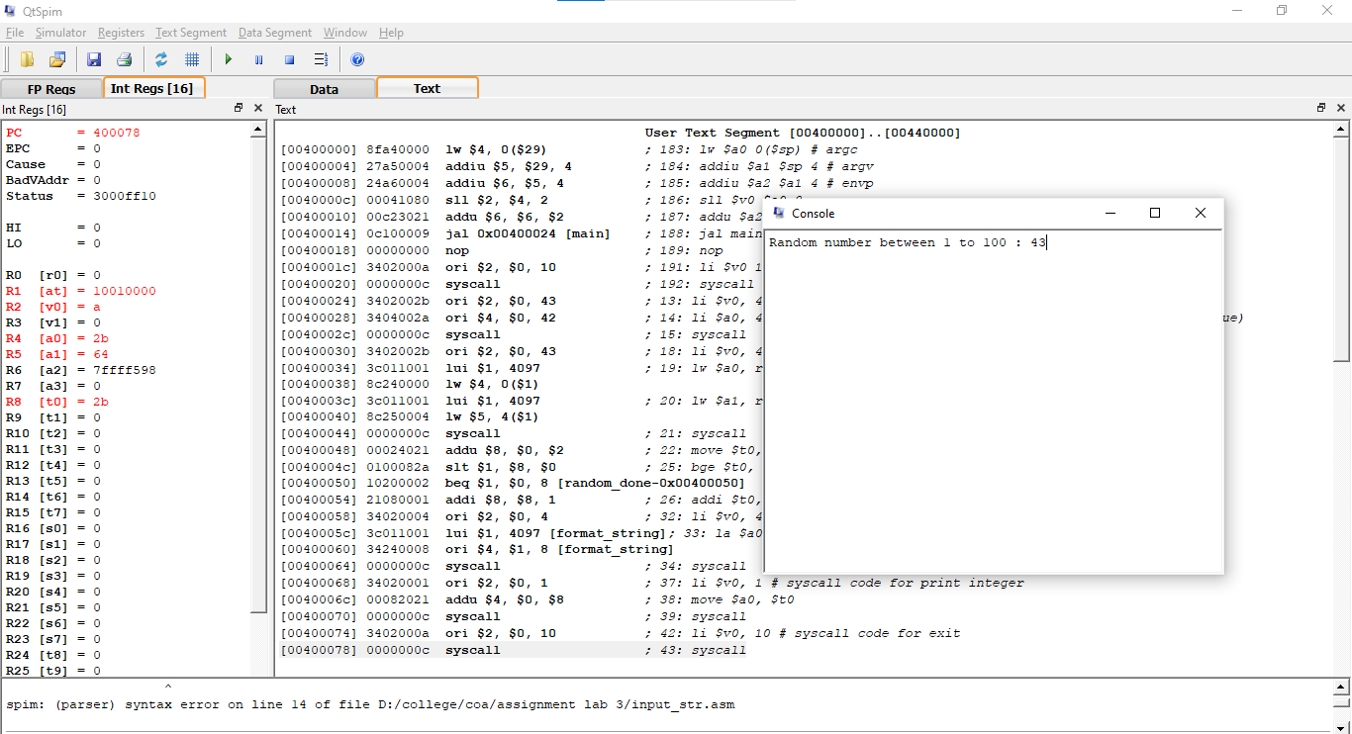

Q5. Write a MIPS assembly program called Problem2.asm. This program should have two global variables, which stores numeric values. The program itself should sum those two values and then print the result to the console.

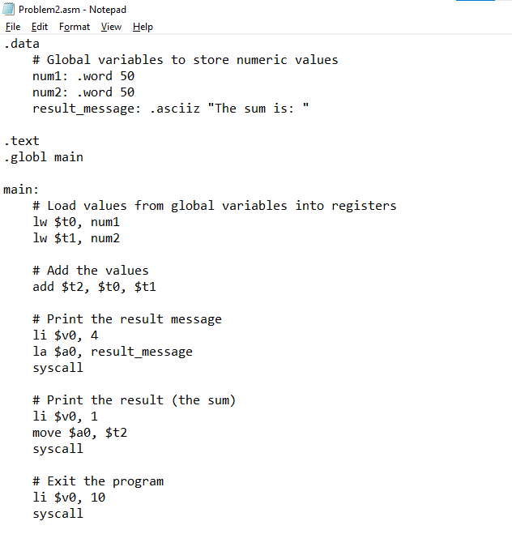

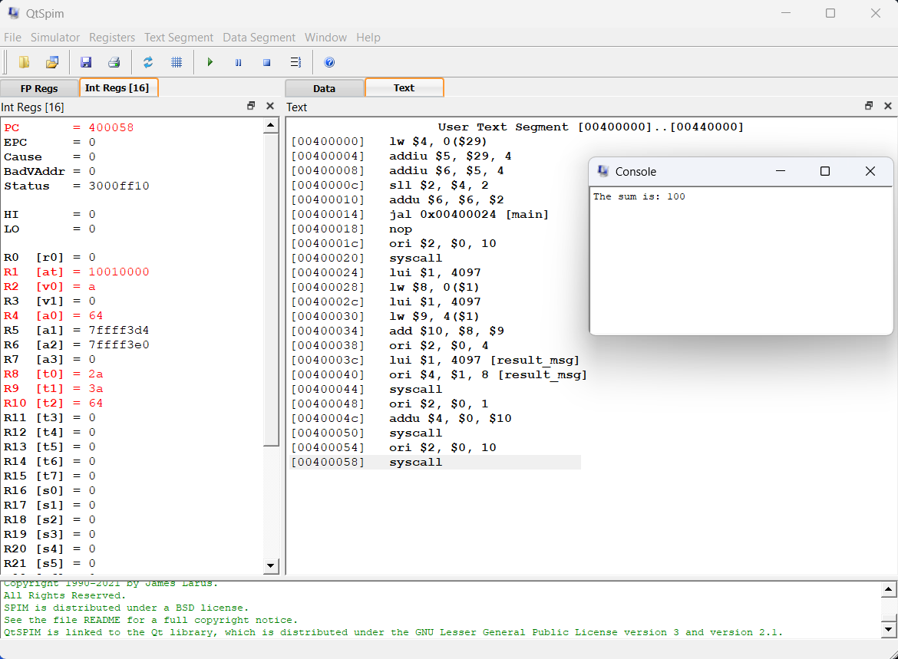

Q6. The program should have two temporary registers , which stores numeric values. The program must have multiply these two numbers and the result is store in the saved value registers.

ANS :

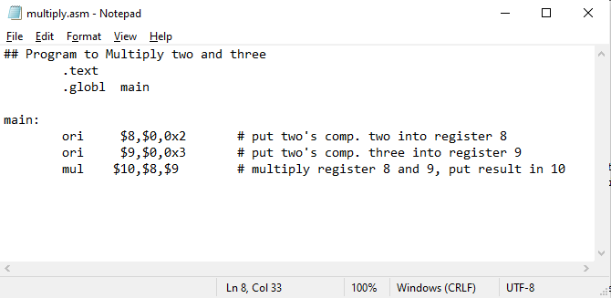

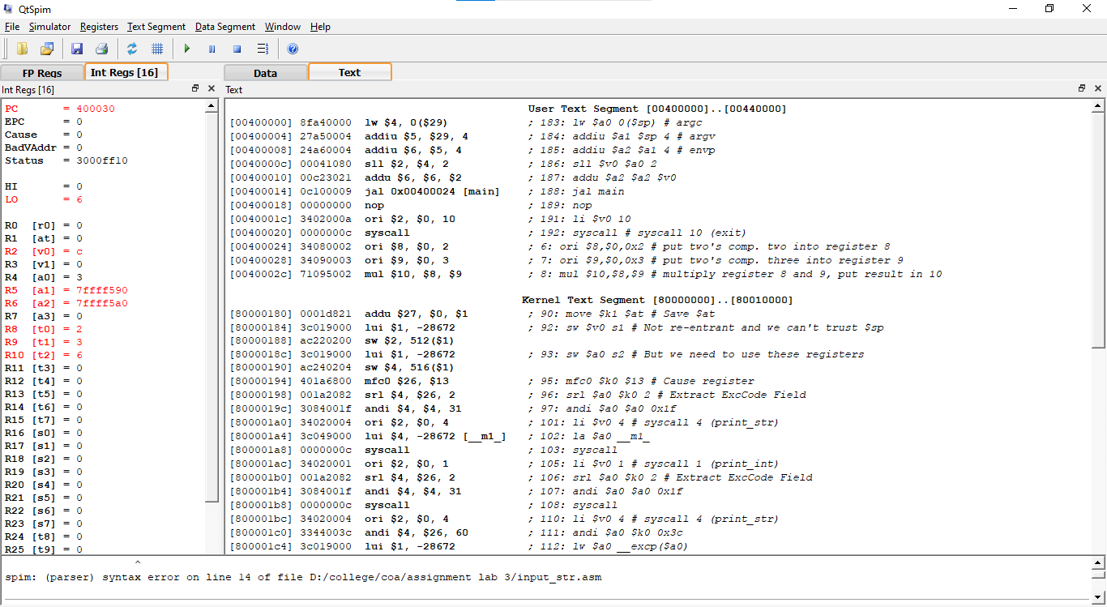

Q7. Write a program to find out the square of an number and print the result to the console.

ANS :

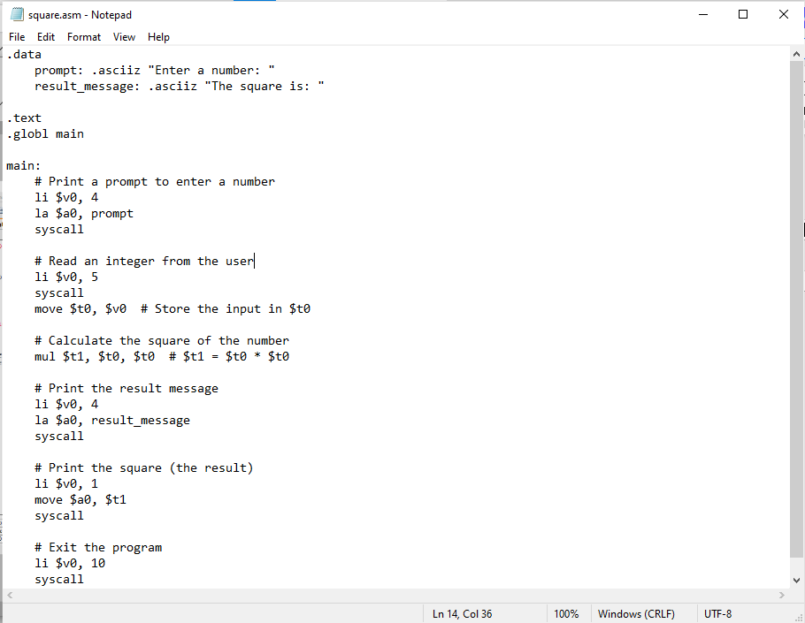

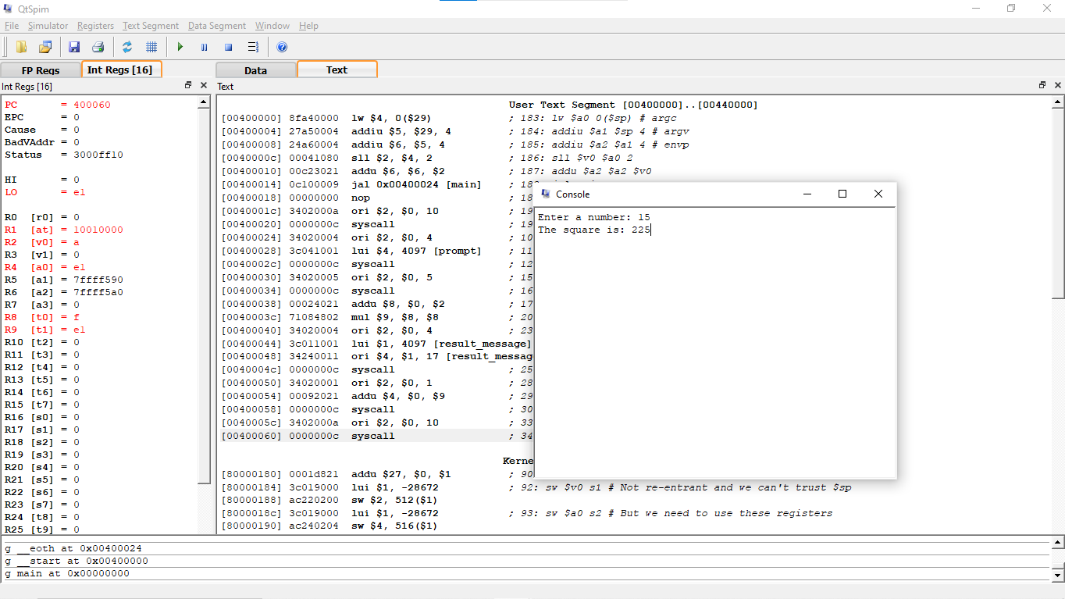

Q8. Convert the following program

ANS :

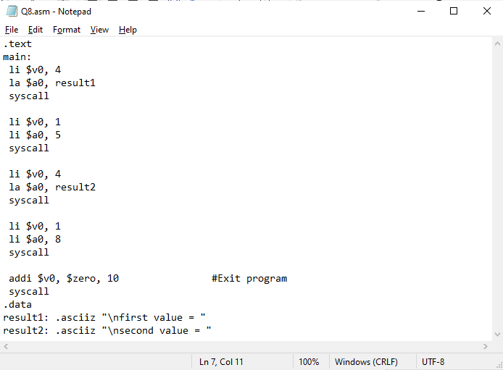

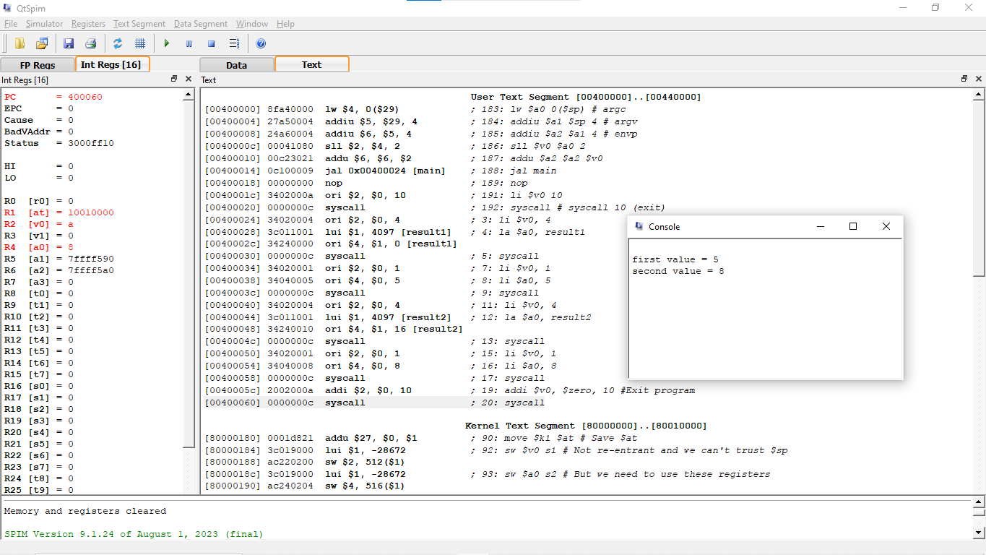

Q9. Write a program to retrieve two numbers from a user, and swap those number using only the XOR operation. You should not use a temporary variable to store the numbers while swapping them. Your program should include a proper and useful prompt for input, and print the results in a meaningful manner.

ANS :

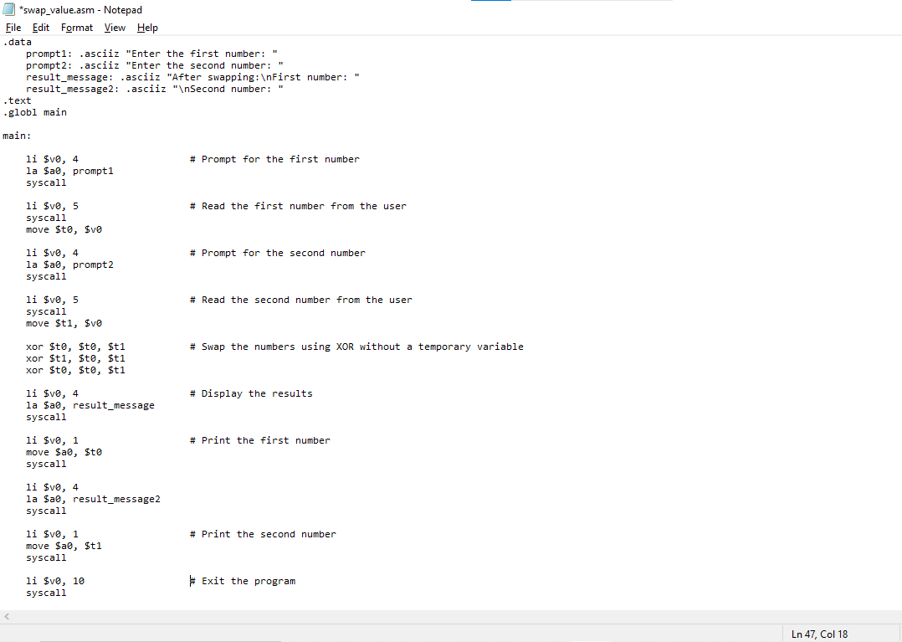

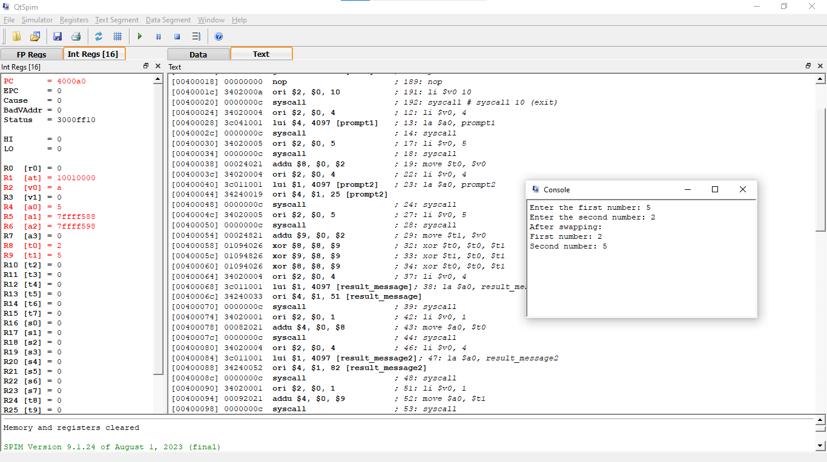

Q10. Write an Assembly code which take an alphabet from user and print the next and previous alphabets on the screen.

ANS :

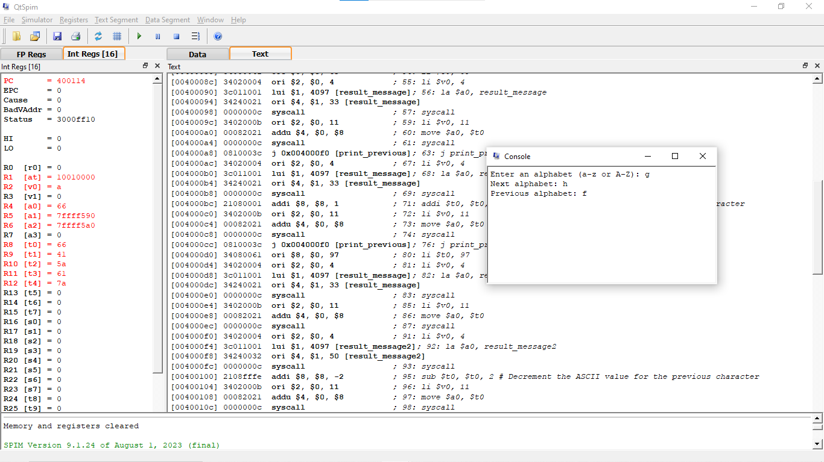

Q11. Implementation of Fibonacci series program In MIPS.

ANS :

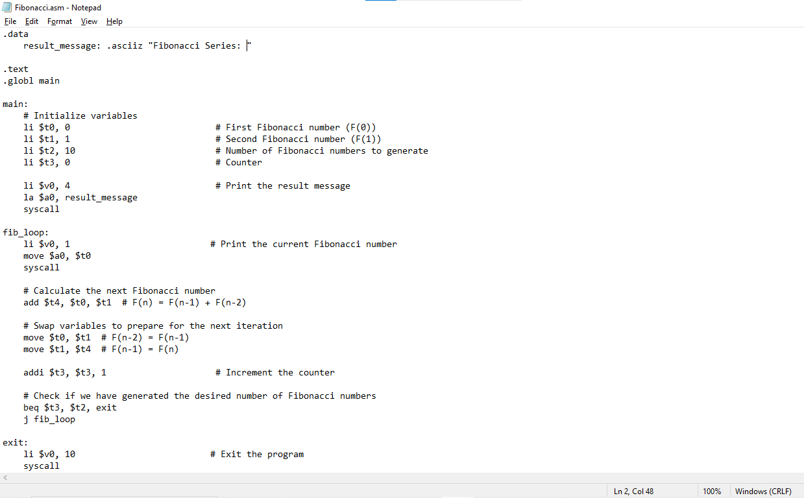

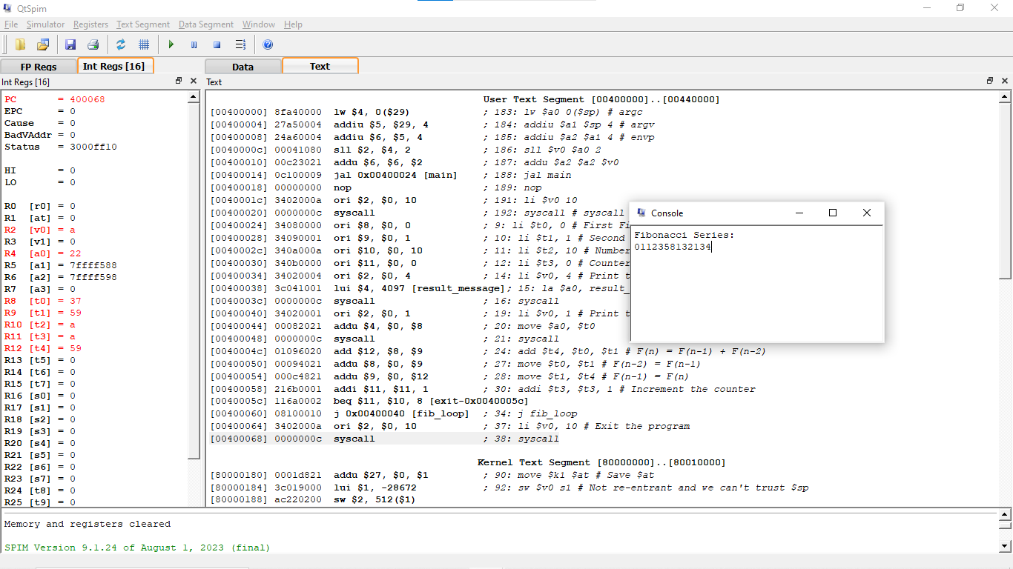

Q12. Write a MIPS program that inputs two integer values. The program should output equal if the two integers are equal. Otherwise, it should output not equal. Use the branch instruction to check for equality.

ANS :

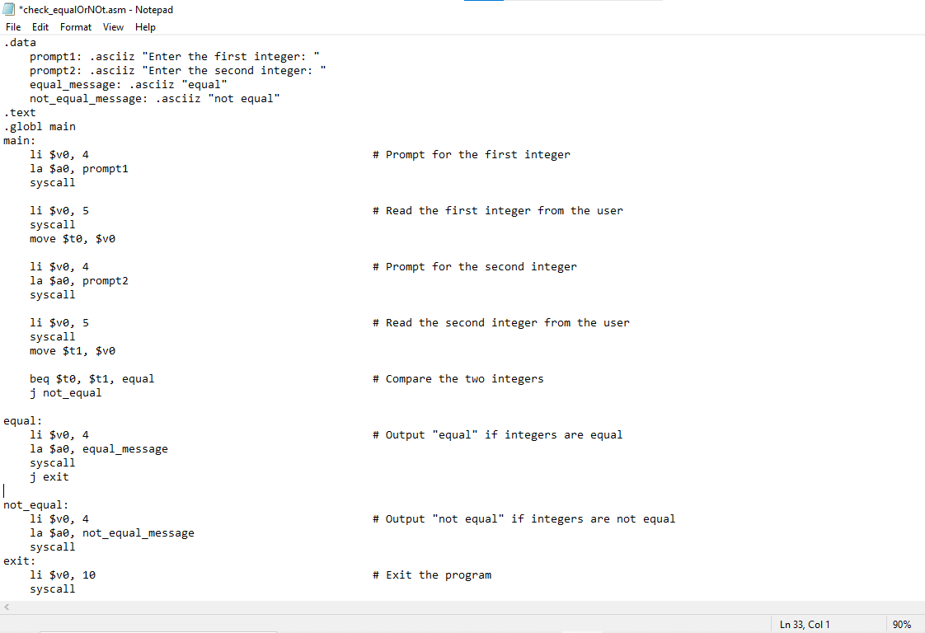

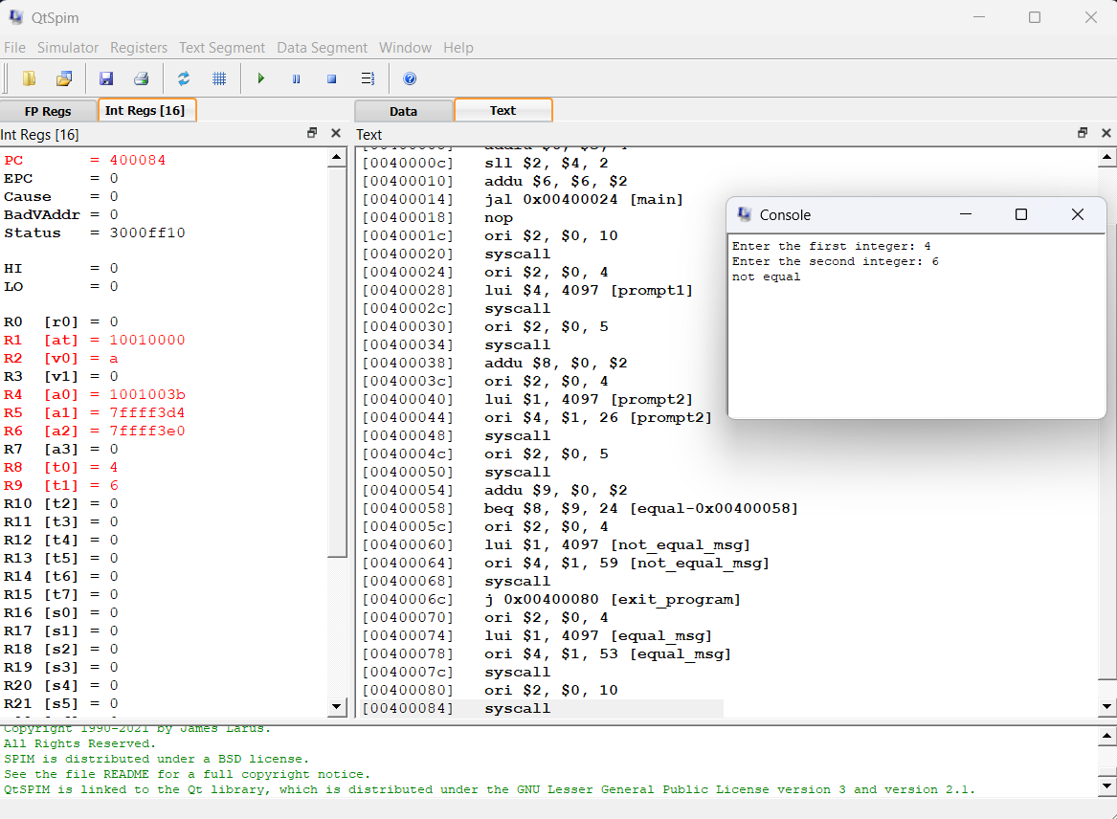

Q13. Variables are of type unsigned integers and word sized. Also the variables b, c, d and e are initialized to values 10, 20, 30 and 40 respectively.

a = (b + c) - (d + e)

ANS : 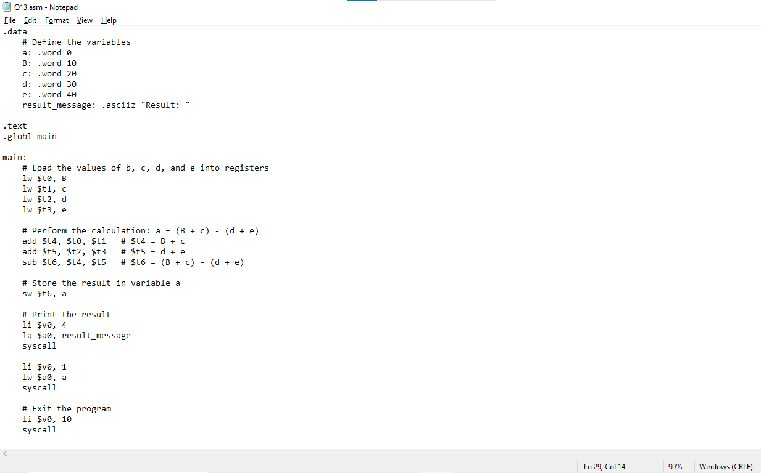

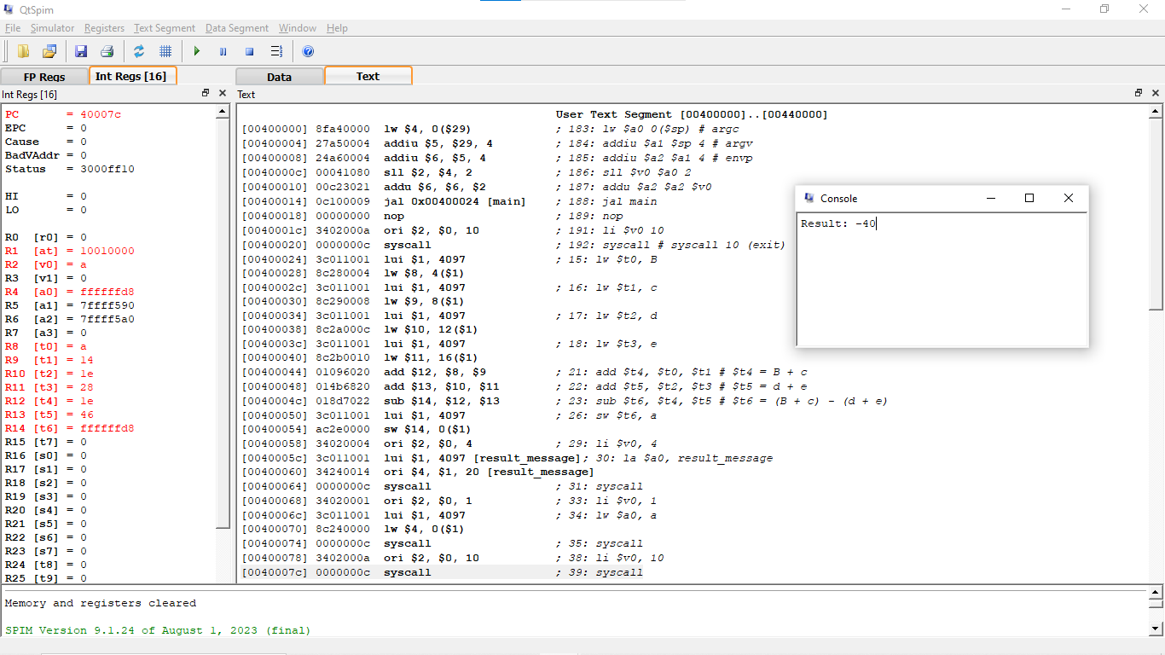

Q14. Write MIPS Assembly Language Programs equivalent to the following C-code fragments.

1. if(a<b)

{ //a and b are signed integers  
 c = a - b;  
}

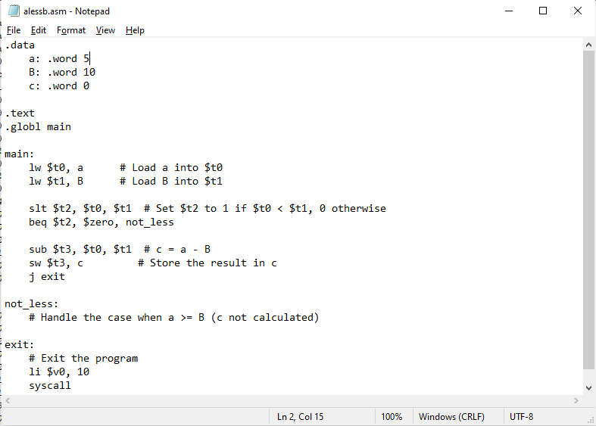

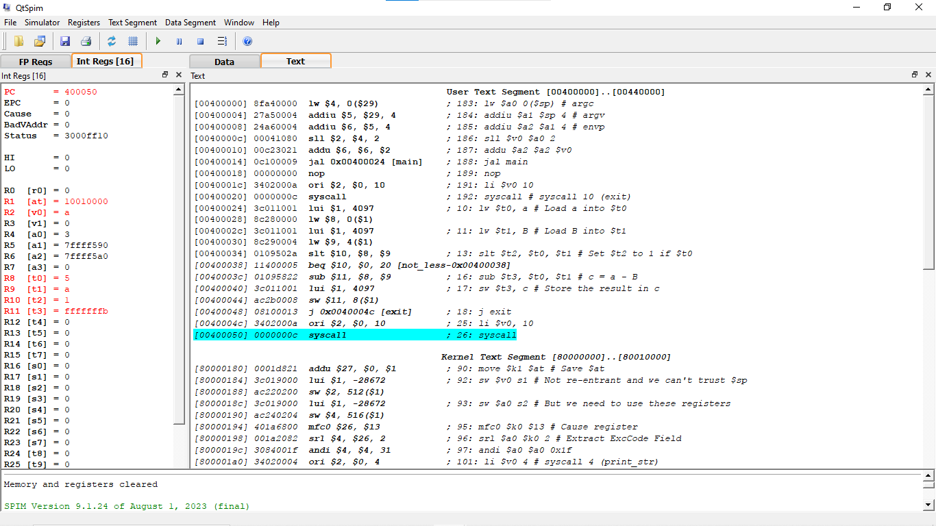

1. if(a<b)

{ // a and b are unsigned integers  
 c=a-b;  
}

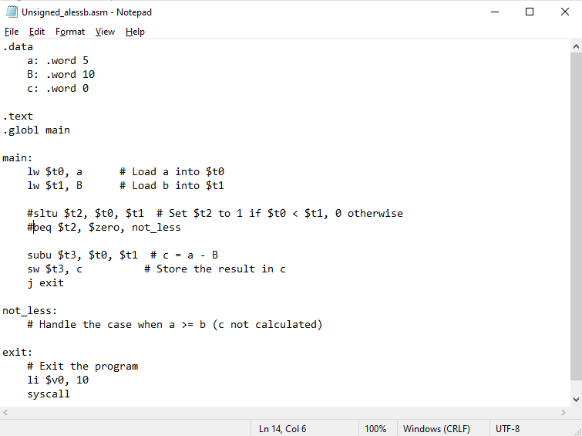

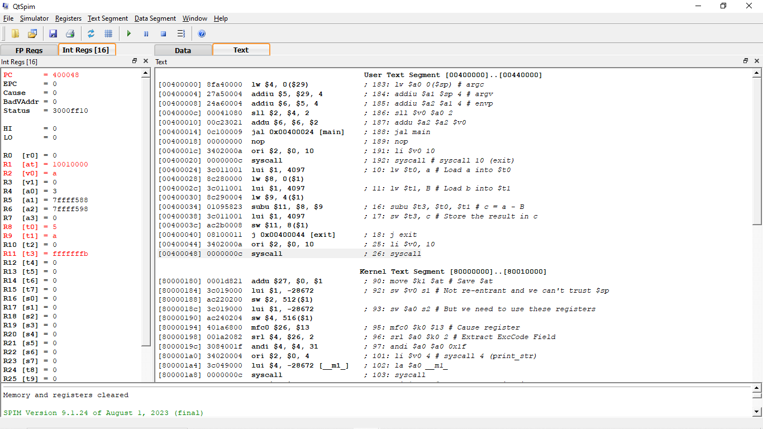

1. if ( a < -1234)

{ // a is a signed integer  
 a = 4 * a ;  
}  
else

{  
 a = a/4;  
}

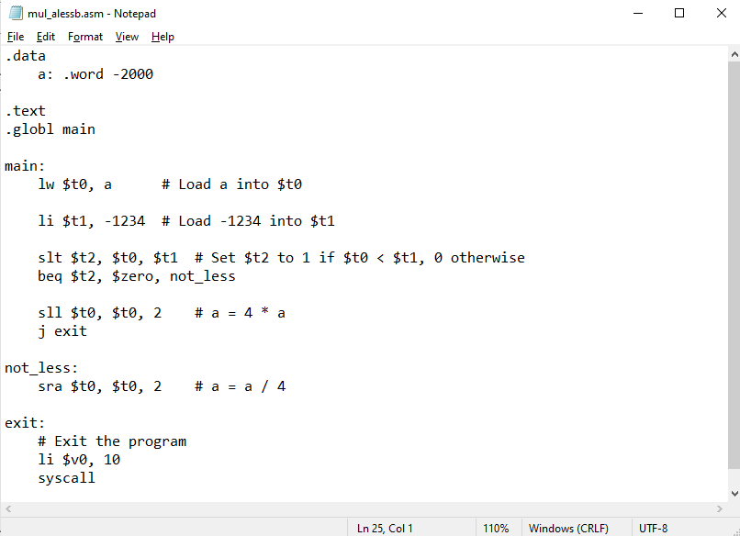

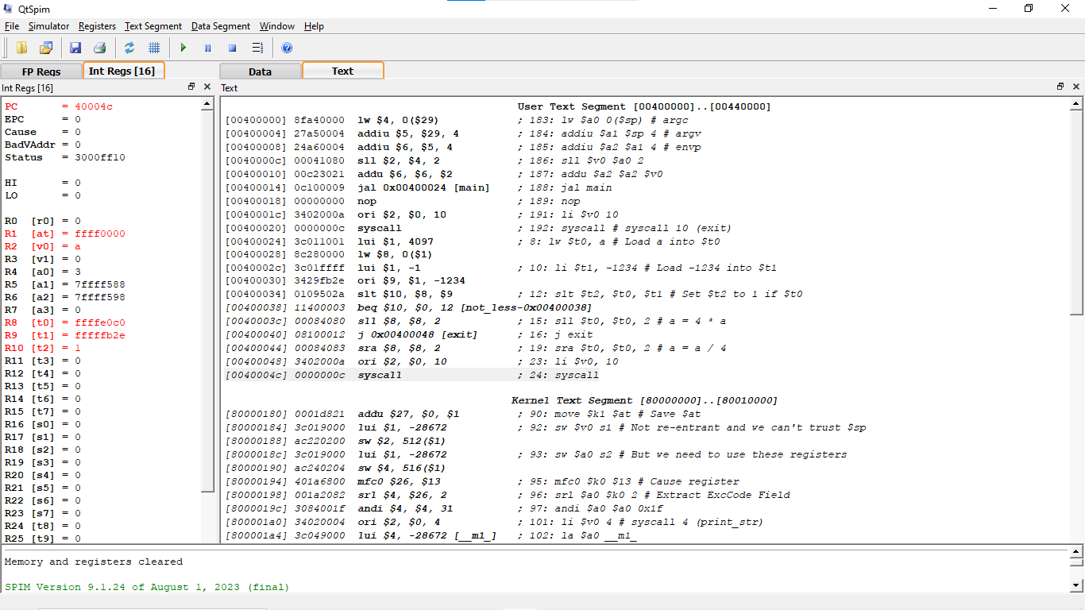

15. Write a MIPS assembly for the following C codes :

int a, b, result

int main(){

a = 0x12345;

b = 7;

result = a + b;

return 1;

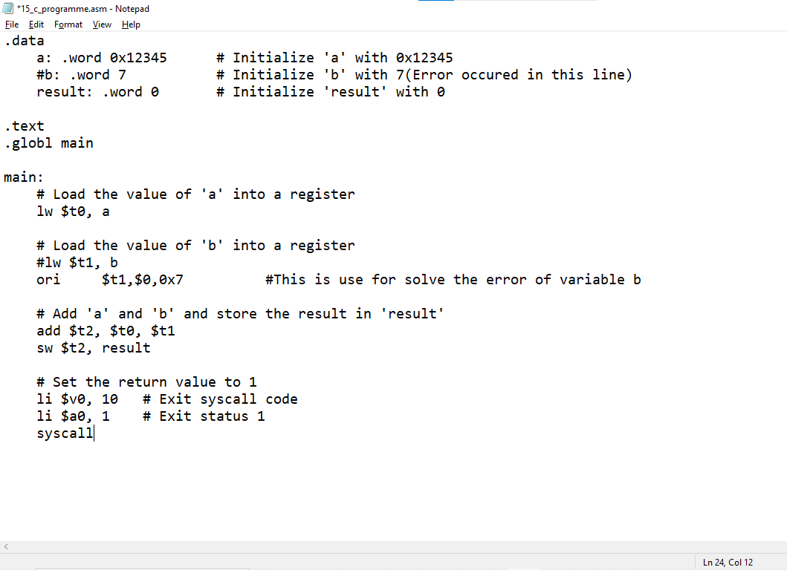}

ANS :

